

Non-Western Art: Extending Our Vision Winter 2015
SFCC, Instructor Patty Haag, Office 106 533-3713 patty.haag@sfcc.spokane.edu

In this 5-credit class, we explore aspects of the human condition through the visual language of world cultures, particularly those of non-European origin. We look at contemporary trends and traditional art forms, and examine the connections between art & culture. This is a “W” writing intensive and a “D” diversity class.

Course Objectives

- Understand what art is & in what ways art reflects the culture to which it belongs.

- Be more aware/have greater understanding of peoples from diverse ethnic/ cultural backgrounds not only in the United States but the international community as well.

- Better appreciate these groups, and to understand in what ways
our American culture has been enriched by their influence.

- To identify major art forms of cultures studied—past and present—and compare and contrast the arts from various groups.

Required Text Schneider Adams, Laurie. World Views: Topics in Non-Western Art. McGraw-Hill, 2004 ISBN-13: 978-0072872026

Attendance is required. Coming late or leaving early counts as 50% absent. Door may be locked after class begins. Students are responsible for info/assignments given in class. Late work may not be accepted.

Compare/Contrast Art Paper Students research/write a 5-6 page typed paper focusing on art from two of the cultures we are studying. All writing will be done in student’s own writing (plagiarized works means automatic failure). Papers due on time.

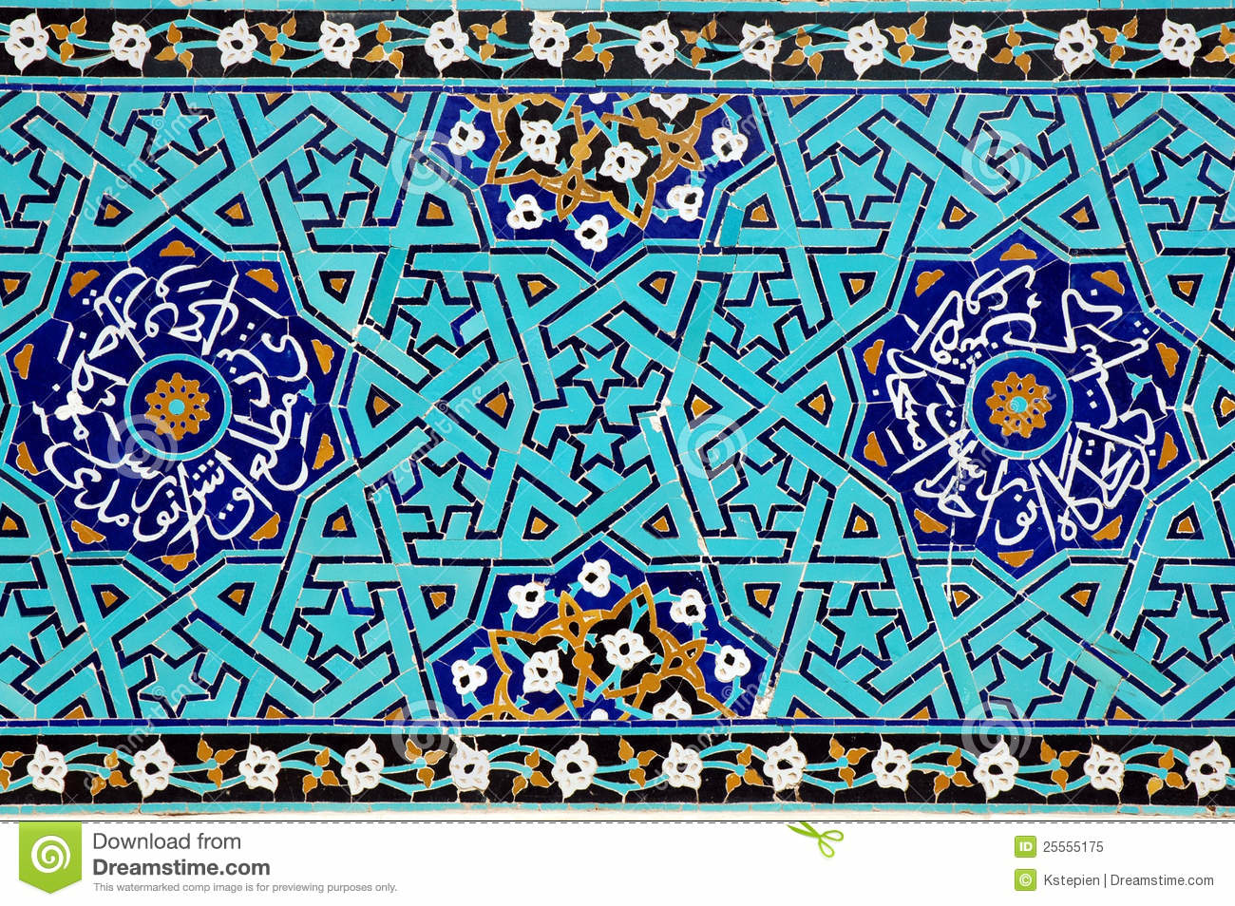

Quizzes & Tests cover all in-class material (readings, notes, slide lectures, discussions, DVDs, speakers etc.). Everyone is required to take final exam in class on the announced day. Make-ups usually given at end of quarter. No make-ups on quizzes.

Participation & Notes Students are expected to keep up with reading assignments, to participate in class discussions, and to take notes on readings, DVD’s, guest speakers & lectures. Plan at least 1-2 hours outside class for every hour in class (10 hours/week).

Activity Report Students may write one 1½ page typed report based on instructor-approved out-of-class activities reflecting a culture studied in class for extra credit.

Evaluation
Tests 50%
compare/contrast paper 30%
homework/quizzes 15%
attendance 5%
If you need to drop the class, do so by the deadline to avoid a failing grade. "Z" and "incomplete" grades only given in emergency situations at the discretion of instructor.

Online syllabus Go to SFCC Home Page, Click on Faculty Websites in the left hand column. Scroll down to ONLINE Syllabus, Scroll down to Haag for Non Western Art 112

Classroom Atmosphere
Courtesy, thoughtfulness, & acceptance are essential in our discussions. Every student has a voice & deserves the courtesy of attentive listening & freedom to express diverse ideas.
If you have a health condition or disability requiring accommodations to fully participate in class, contact me or Disability Support Services Blg 17-201, 533-4166. Info confidential.

Electronics
Keep cells turned off & never any texting or student may be asked to leave. Do not e-mail your assignments & expect instructor to print them for you.
Library free access to computers/printers 533-3805
M–W 7:15a.m.–7:00 p.m.; Thurs/Fri 7:15am.–4:p.m.; Sat: noon-4 p.m. Sun: CLOSED

Counseling Center Building 30, Upper Concourse, Room 243 533-3525
Academic & personal assistance. Drop-in, or make appointment, no charge. M-F 8-4:30pm

SFCC Communications Learning Center Building 5 Room 113 533-3604
Credit/non-credit, reading comprehension, vocab building, writing, editing & study skills.

Student Peer Tutoring http://www.spokanefalls.edu 533-3933
Free for all SFCC students to work with tutors on writing papers and study skills

Academic Consulting Mybigfoot
If you have fewer than 30 earned credits, you’ll meet with your assigned academic consultant (ac) during the 5th or 6th week of the quarter to plan for following quarter.
Find your AC & contact information in Mybigfoot.

Early Alert System SFCC homepage, EA button
This class uses the early alert system. If students struggling academically or have poor attendance they will receive notice from early alert to connect them with support resources. If you are contacted about an early alert, please respond ASAP so you can
get the support you need to be successful in this and other classes.

SCC Student Health Clinic/Walk-in Sick Call Clinic 533-8611 SCC Campus Greene Street, Building 9 Room 149, M-Th 8am-1pm; F 8-noon

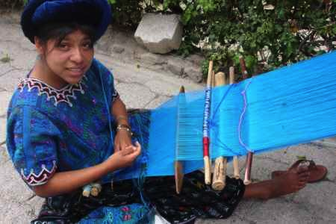

Winter 2015 M-F 9:30am room 140
Jan 5 – Mar 24 Classes

Jan 14, 15 Meet in library upstairs, room 211; bring handouts & laptops

Jan 16 DUE: outline & MLA sources

Jan 19 Martin Luther King Day – no class

Jan 21 Speaker Saul Williams, SUB 11:30am

Jan 29 DUE: Compare/contrast notes due

Feb 4 DUE: thesis statement/peer edit

Feb 11 Wendy Red Star, Lecture, 11:30am Building 24 room 110

Feb 13 Library Day

Feb 16 Presidents Day – no class

Feb 18 DUE: compare/contrast polished draft w commentary

Feb 23 Final day to withdraw

Feb 23 – 27 Intercultural Week, SUB

Mar 3 Photo check – bring 6 images for paper

Mar 5 DUE: Compare/contrast final paper with photos due

Mar 20 Dead Day

Mar 24 Final class – 2 hours long and required



